September 2018

Dear Parent/Carer

As we approach the end of week four, we would like to say thank you for all of your support over the last month. Ensuring your child is ‘school ready’ can be an expensive and busy time. We are so pleased with the smart appearance of our students and understand that this relies on the support from home.

As a school we are always looking to improve communication with our parents; with this in mind recent feedback from some of you is that a bit more clarification on shoes might be helpful. Our website states sensible plain, black shoes – trainers, boots and ‘ballet’ style shoes are not allowed. Moving forward, when you buy shoes for your child we would request that you buy a full lace up brogue/shoe, or alternatively a sturdy black shoe that covers most of the foot that would withstand inclement weather. Boots are not permissible; this includes the heavy work boot look that some of our boys want to wear. Below are examples of suitable shoes:
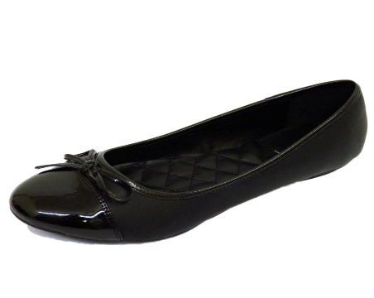
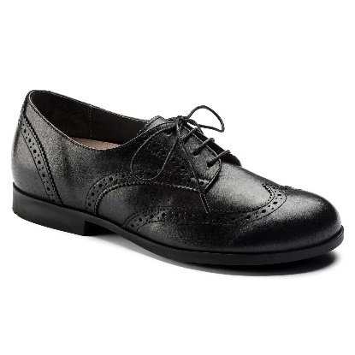
Girls:
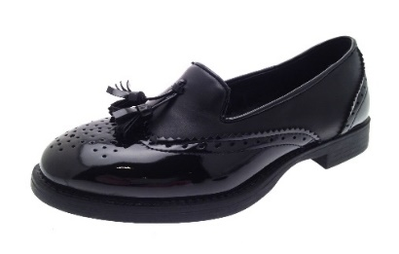

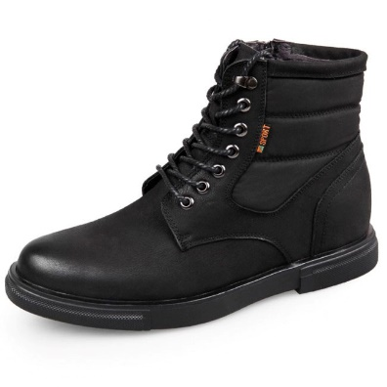
Boys:
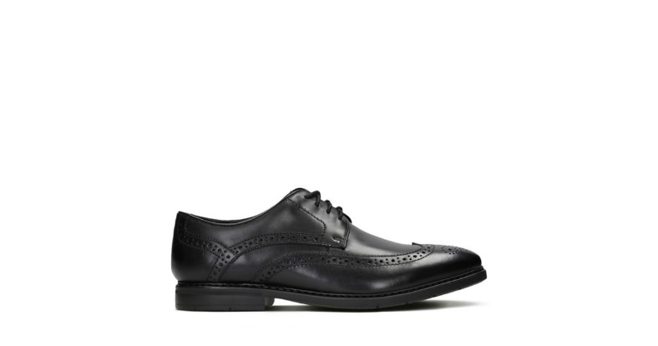
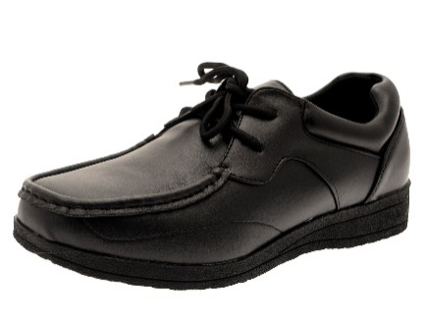

Q

As you are aware, our school trousers can only be bought from Cliffs, however we appreciate that often one style does not always suit or fit all. With this in mind we have asked Cliffs to ensure parents/carers are aware that there is a choice of appropriate

trousers so that you might secure the best and most comfortable fit for your child. The school have asked that Cliffs offer any alterations to parents/carers if this helps with sizing, which can be a sensitive matter.

We have also asked Cliffs to ensure alternative lengths in skirts are available – 18” 20” and 22”. Cliffs can also make a particular skirt longer if required. However, if the sizing of skirts is a particular problem for girls then we advise that your child should wear trousers.

We would like to take the opportunity to ask that you ensure your child has an appropriate school coat, especially for the winter months. Body warmers and hoodies are not allowed and will be treated as a uniform breach. Some students appear to arrive at school without any outdoor wear which can mean that they can be sat in wet clothing during lessons. Similarly, whilst waiting for the buses at the end of the day some children appear very cold which I am sure we all would wish to avoid.

You may well be aware our students now only enter and exit school by the main entrance. To ensure an even greater orderly start and finish to the day we have increased staff presence at these times. Unfortunately some people inappropriately use the turning circle outside school to collect their child. We ask that parents/carers do not park in the turning circle outside school to pick up their child. Students no longer are allowed to cross over that area, due to health and safety protocols, so it would be advisable for parents to park on the main road if ‘picking up’ is essential.

Thank you once again for your support. We have enjoyed a positive, calm start to the academic year. We are sure by working together we can continue to support your child to reach their full potential. If any parent would like to work more closely with the school, giving feedback and helping us to shape daily practice, you are very welcome to join our Parents Advisory Group. Our first meeting is at school on Monday 22nd October at 6pm until 7.00 pm.

Yours sincerely
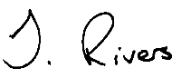
Mrs H Redford Mrs J Rivers
Headteacher Deputy Headteacher

