11 January 2019

Dear Parent/Carer

Today your child has been given their mock examination results in a special assembly.
The aim of this was to give them a taste of what it is like to open ‘that envelope’. This gives both you and your child a benchmark of where they are at currently and just how much more needs to be done before the final examinations in the Summer term.

We hope you are able to support your child, and the school, by discussing these grades and future steps with them. Although there are rigorous revision programmes scheduled for each subject by the school over the coming months, both during the school day and through intervention sessions, it is imperative that they also make good use of their time at home in preparing for the exams, and set themselves a bespoke revision schedule to enable them to do this.

The Record of Achievement report will follow these mock examination results at the end of January highlighting projected grades and scores for attitude to learning and home learning. A Year 11 Parents’ Evening will take place between 4.30-7.30 pm on Thursday 7th February 2019.

Should you wish to know any more information please do not hesitate to contact the school.

Yours faithfully

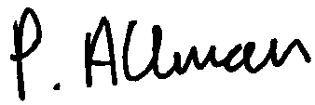

Mr P Allman Assistant Headteacher

