Dear Parent/Guardian,

National Citizen Service Summer 2019

The NCS Team has recently visited school to offer our students an amazing opportunity on the National Citizen Service (NCS) in
Summer 2019.

NCS has become the country’s fastest growing youth movement with over 500,000 graduates to date. This once in a lifetime opportunity is a 3 week programme that helps young people build their confidence and gain new skills while having fun and giving back to their community – providing the best possible springboard for their future. Whether they’re planning to apply for university, or preparing to enter the working world, signing up to NCS is one of the best decisions a teenager can make. Club Doncaster has been delivering NCS for 4 years with over 2,500 teenagers graduating from the programme.

NCS is a 3 week programme run over 4 different phases, Adventure, Discovery, Action and Celebration. Participants go on a journey, heading to various places around the UK to do exhilarating outdoor activities, having a University experience building up skills for their CV’s, preparing and delivering a project designed to help the local community and an incredible graduation celebration at the Doncaster Dome

The NCS programme is something that every teenager should have the opportunity to participate in, and so to help make this a reality, the Government is willing to invest over £1000 in your child to allow them to have that opportunity. All they ask for is just a maximum of a £50* contribution from you to give your child a 3 week experience that will change their life. Even better, if you sign up online through ncsyes.co.uk, a place will cost you only £35!

*Bursaries are available on a case by case basis and support is provided for young people with additional needs.

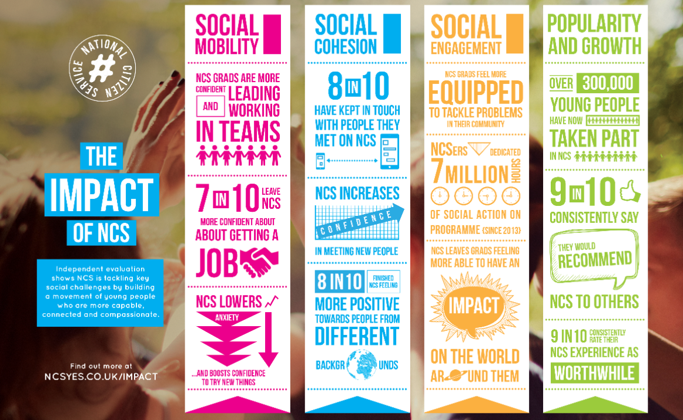

We firmly believe that this is the best way for your teen to be spending their summer, but don’t just take our word for it…..

“My daughter has had an amazing 3 weeks and has come away with some great memories and made some lovely friends. It's been a really positive experience and at not much cost either. Thank you so much for giving her this opportunity”- NCS Graduate Parent

“On NCS our students meet people from different backgrounds, take on new challenges and, perhaps most importantly, learn about the community and how they can make a difference. This means that not only do young people return more confident, resilient and eager to learn but they are often much more eager to volunteer and help out in their local community.” - Local Head of Year

There are limited spaces on the NCS Programme and they are filling up fast

How to find more information or book a place?


Visit www.ncsyes.co.uk for more information and to book a place and take advantage of the online discount.


Phone the NCS Office on 01302 764663 for chat about the programme and to reserve a place for your child. Office hours are 9am until 5:30pm.


Also, you can find us on social media @ncs_doncaster on Instagram and NCS Doncaster on Facebook and Messenger

If you would like any other information or have any questions, please do not hesitate to get in touch.

Reward your teen with a summer they will never forget!

Kind Regards Kind Regards

The NCS Team Mrs Gratton, NCS Coordinator
​ Hungerhill School

01302 764663 01302 885811 ext 236
ncs@clubdoncasterfoundation.co.uk Gratton.l@hungerhillschool.com


​

