01 May 2019

Dear Parent/Carer,

On Monday 8th July parents of Year 10 students are invited to attend the ‘Making Mocks Matter’ evening that will coincide with students being able to collect their mock exam results. In order to accommodate all students and their parents/carers, there will be a staggered start to the evening with the option of arriving at 5:00pm or 6:00pm. The evening will include:

- mock exams results collection with short presentation
- key dates and information for achieving success in Year 11
- revision strategies and advice to best support students

Attendance at the evening will be essential for all students and parents. A large part of the ‘Making Mocks Matter’ evening will focus on preparing students for the new linear exams. During this part of the evening students and parents will have an opportunity to experience a range of revision strategies so that they are able to support their children further in their learning. The information shared will feed into the ‘Masterclass’ weeks for Year 10 students.

These ‘Masterclass’ weeks will be taking place directly after work experience for two weeks, beginning the 8th July 2019. The Year 10 cohort will complete two weeks of ‘Masterclass’ sessions where they will spend the equivalent of one day intensively studying each of their GCSE subjects. By providing this opportunity, students will have time to enable them to 'master' and cover specification material in greater depth. Evidence shows that mastery learning can provide up to 5 months accelerated progress for students. These weeks will be pivotal in completing and reviewing key aspects of their GCSE courses. They will involve completion of field trips and working through pre-release material. The departments involved will also be looking to complete controlled assessments and review and consolidate key points of the course. This is a fantastic opportunity to prepare students for the demands of Year 11. This time will not be repeated so the attendance of your child at these weeks is imperative.

Your support with this is appreciated.
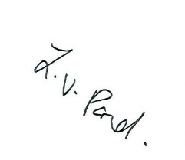
Yours sincerely
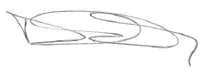
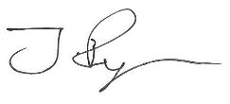

Mrs L Pond Mr J Ryan Mr D Parry
Head of School Associate Assistant Headteacher Achievement Leader

