Dear Parent/Carer,

We are writing to provide you with more information about the Y10 ‘Making Mocks Matter’ event taking place on Monday 8th July 2019 at Hungerhill School. As we move closer to the event we would like to once again stress the importance of attendance for all students, with at least one parent/carer. We would also like to provide you with further information about the evening.

As mentioned in our previous letter, the evening will provide an opportunity for students to collect their mock exam results, before observing a short presentation and attending a revision techniques session with parents/carers. In order to ensure we can cater for all guests we will be operating an electronic booking system with two available time slots - 5pm & 6pm. The booking system is quick and easy to use and shouldn’t take more than a few seconds to complete. Please follow the link below to book on to one of the two available time slots or to let us know that you will be unable to attend. Spaces will be allocated on a ‘first come first served’ basis.

https://www.surveymonkey.co.uk/r/2NWFDPC

We look forward to seeing you on Monday 8th July.

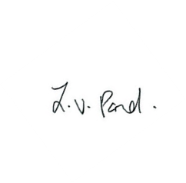
Yours sincerely

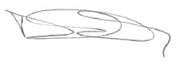
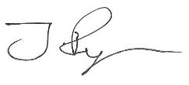

Mrs L Pond Mr J Ryan Mr D Parry
Head of School Associate Assistant Headteacher Achievement Leader

***THIS IS AN AUTOMATED MESSAGE - PLEASE DO NOT REPLY DIRECTLY TO THIS EMAIL***

