June 2019
Dear Parent/Carer,

CAST, in partnership with Lung Theatre, have offered our Year 7 students the fantastic opportunity to watch ‘Who Cares’, a play created with and written about the experiences of Young Carers. Students will also have the chance to partake in a workshop with the cast of the play. There will be no cost to parents/carers for this opportunity.

We have been allocated Thursday 27 June for the workshop, which will take place at Hungerhill School and Friday 28 June for the performance, which will take place at CAST in Doncaster town centre.

Forms 7G, 7R, 7I, 7L and 7S
These forms will attend the performance on Friday morning, registering in school as normal and then departing at approximately 9.20am to travel to CAST by coach. The performance will finish at 12noon when students will be brought back to Hungerhill, having lunch P4b and then attending their normal lessons Period 5 and 6.

Forms 7H, 7U, 7N and 7E
These forms will attend the performance on Friday afternoon. They will be in normal lessons Periods 1 to 3 and have an early lunch period 4a. They will depart Hungerhill at approximately 12.20pm to travel to CAST by coach. The performance will finish at 2:45pm when students will be brought back to Hungerhill, in time for the normal end of the day routine.

Could you please return the reply slip below by Monday 17 June to give your permission for your child to attend.

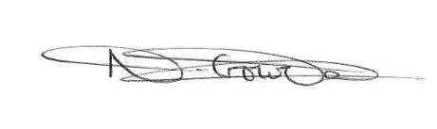
Yours sincerely,

Miss N Crowder
Curriculum Leader for Performing Arts

REPLY SLIP RE. Y7 CAST PERFORMANCE ON FRIDAY 28TH JUNE TO BE RETURNED BY MONDAY 17TH JUNE

I do/do not* give permission for my child to attend the performance at CAST theatre on Friday 28th June 2019.

Student Name: __________________________________ Form: ____________________

Signed: _________________________________________ Date: _____________________

* Please circle as necessary

