22 November 2019

Dear Parent/Carer

We are very pleased to invite you to a Parents’ Evening on Wednesday 11th December 2019 from 4.30 – 7.30 pm to discuss your child’s work and progress with subject teachers.

At this event, your child will also be able to receive their mock examination grades. These will be available from 4.15 pm.

We are aware that Hall Cross School have recently altered their post 16 evening for the same date of 11th December. Hungerhill and Hall Cross are ensuring that arrangements are being made to provide an opportunity for your child to visit Hall Cross on an alternative date in the new year. We will provide further details once we have received confirmation of the new date.

This is a very important evening as it will be an opportunity for you to meet with your child’s subject teacher before the GCSE examinations and we do hope that you will be able to attend.

To confirm whether you will be attending the above evening please access the following link and complete the survey as soon as possible, preferably by Monday 2nd December 2019.

https://www.surveymonkey.co.uk/r/5NR8H7L

If you are able to attend your child will be given an appointment sheet which will be used to arrange appointment times with subject teachers. It will be a busy evening, so please do keep to the times arranged.

We strongly advise that you bring your child with you for this important consultation. We look forward to meeting you.

In order to meet our duty under the Disability Equality Scheme, please advise us if there are any ways we can assist you in this event. I would be grateful if you could let Mrs Kenny know by telephone on Doncaster 885811 or by e-mailing to kenny.v@hungerhillschool.com. Please note that all the information provided will be treated confidentially.

Yours sincerely
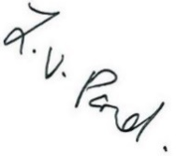
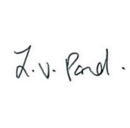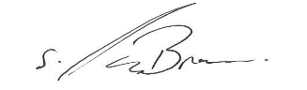

Mrs L Pond Mrs S Parker-Browne
Interim Headteacher Deputy Headteacher

