14 February 2020

Dear Parent/Carer,

It is with regret that we are sending this letter to inform parents of the malicious behaviour of some of our students. It has come to our attention that a number of social media sites are being set up and our teaching staff are being targeted with derogatory comments posted about them on these profiles. This serious matter is currently being investigated by the police.

Please may I ask you, as a matter of urgency, to speak with your child about responsible use of social media and urge them to cease all contact with any of these profiles and remove themselves as a follower.

Any student to be found posting on these profiles will be at risk of a permanent exclusion.

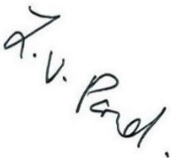
Yours sincerely

Mrs L Pond
Interim Headteacher

