06 April 2020

Dear Parent/Carer,

RE: Reading at home

Hungerhill School has always recognised the ability to read as the cornerstone to a good education and great results and as such we work hard to ensure students prioritise reading skills in the classroom. We don't want to ignore this important part of their education whilst learning from home and the benefits of just reading for 15 minutes a day are widely known to have close correlation with students' success in the classroom and in the workplace. As we are a school invested in Accelerated Reader, they have informed us that we are able to access over 7000 books on a new platform they have created.

This is free to everyone and caters for children from Reception through to Y10+. The wide range of both fiction and non-fiction books means there is something for everyone and it can be accessed through the following link: https://readon.myon.co.uk

The texts on this platform can be filtered through the search facility by a number of different things- but the most relevant for your child might be their 'Year level' which will narrow the text for their year group. Furthermore, you can then filter by Fiction or Nonfiction depending on preference.
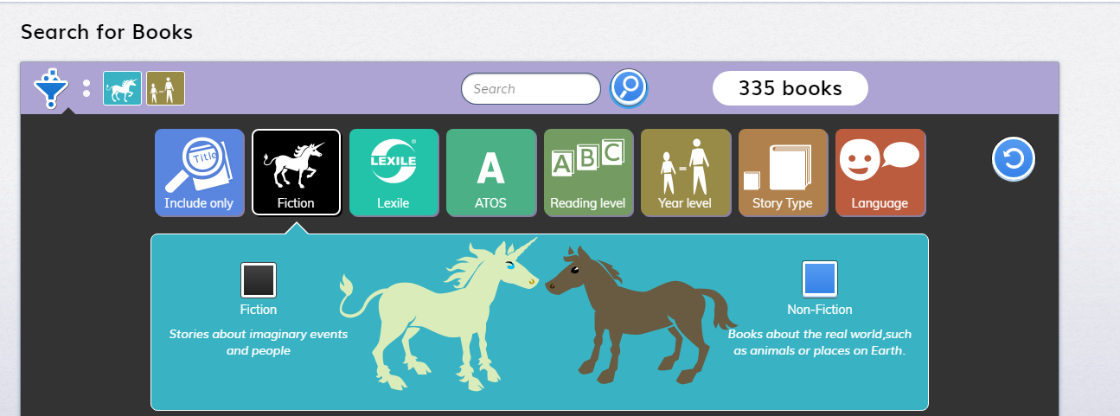

Our intention is for the English Department to use this as part of your child's learning experience after the Easter break. In the meantime, we wanted to share this resource with parents/carers so that students have access to this virtual library over the Easter holiday to allow them to select a book of their choice and allow them to read for pleasure.

After Easter, students will be asked to choose something they would like to read and then complete a short review which will be added to Teams- our new learning platform-and shared with other students in their class. They will also be able to use this to discuss their reading if they so wish. This can, of course, be a book from home or one that they may already be reading. The attached link is to give them a virtual library at a time when they may not be able to access books as they once did.
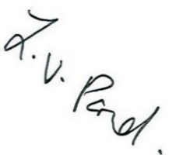
Yours sincerely

Mrs L Pond Mrs S Hunt
Interim Headteacher Associate Assistant Headteacher
and Strategic Lead for Literacy

