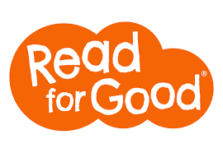






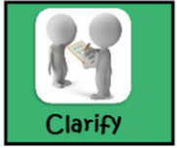

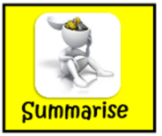
“If you can only do one thing with your child during lockdown, choose reading for fun. Reading together, or on their own, is proven to help children keep up with education, it’s away from a screen, it relaxes them (and you) and it helps them process what’s happening in the world.”

“Reading for fun can help us through these challenging times.”
Don’t forget to use your Reciprocal Reading Skills:
Below are the four stages used within RR, use the questions sentence stems for each stage to help your child develop their reading skills.

Summarise - to retell the most important events or information from a text.
Predict - use your knowledge to make guesses about what might be next.
Prediction stems:
• Based on the title, I predict that…
• I already know ____about the topic/story because…
• I think the next chapter or section will be about...
• Based on what __ said/did, I predict…
Clarify - to check the understanding of difficult vocabulary, sentences and ideas within a text.
Clarifying stems:
• I don't really understand ...
• A question I have is ...
• A question I'd like answered by the author is ...
• One word/phrase I do not understand is ...
Question - to help develop a deeper understanding of a text and its purpose.
Question stems:
• Who is …?
• What is/does..?
• Why is … important?
• What is your opinion on …?
Summary stems:
• This text is mostly about ...
• The author is trying to tell me...
A framed summary sentence:
This story/passage begins with ___, discusses or develops the idea that ___, and ends with ____.

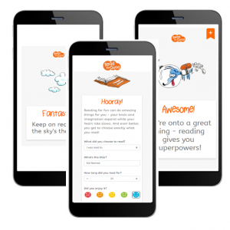
Reading is fundamental to your child’s vocabulary and progress and is proven to increase their life chances. Here are Hungerhill School, we use Reciprocal Reading strategies to maximise reading skills. It is important to ensure that, as a parent, you question your child’s understanding as they read. Use the question stems we’ve provided to help.

Introducing Track My Read!

“Track My Read is a new, free-to-use tool, designed to help you engage pupils in reading for pleasure. It’s really easy to set up, and enables pupils to tell you what they’re choosing to read, and for how long.

It unites a community in reading to achieve a collective target. Pupils are motivated as they get instant feedback on their reading achievements, while at the same time contributing to the school’s overall target.”

Originally designed for schools, any group, team, book club or family can use it – think of it as Strava for reading! Just enter your group’s name where it asks for School Name and you’ll have the chance to enter it manually.”

Please go to the ‘Read for Good website’ for all FAQ’s: https://readforgood.org/track-my-read-faq/
Track My Read - Helping children to love reading!
Reading for pleasure - whether reading on their own or sharing a story - is one of the best ways a child can spend their time.
Research shows that:
- Reading each day can help children improve in all their school subjects
- Reading for just 6 minutes a day can reduce stress by 68%
- Children who read for pleasure are more likely to do well at GCSEs
Choosing to read provides all sorts of benefits - it’s comforting, relaxing, reduces anxiety, builds empathy and understanding and aids learning... but above all it’s fun!
Track My Read is a new tool from national charity, Read for Good, designed to encourage pupils to read regularly and to help schools understand more about what and how pupils want to read.
We’ve set our pupils a reading challenge as a group - to read a certain number of minutes - and we’d like your child to participate. The organising teacher will see your child’s responses, but no-one else will.
Your child will be given a unique URL link with a few short questions to complete each time they’ve spent some time reading for fun:
- Go to the unique link provided by the
school (on any device with internet
access)
- Bookmark or save the link so that they
can easily use the link again and again
- Answer a few simple questions:
  - What did you choose to read?
(from a dropdown list including
audio book, comic, book etc.)
  - What's the title'?
  - How long did you read for?
  - Did you enjoy it? (a choice of 5 emojis)

Please encourage your child to complete this each time they read anything for fun. They will see different encouraging messages as they report their reading, and they will be contributing to the school’s reading target.
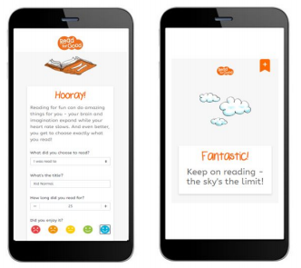
For more information on Track My Read visit:
www.readforgood.org/track-my-read.

