Spring 2023 Practice Paper
Aiming for 5
Instructions
- Use black ink or ball-point pen.
  - Fill in the boxes at the top of this page with your name,
centre number and candidate number.
- Answer all questions.
- Answer the questions in the spaces provided
– there may be more space than you need.
- You must show all your working.
- Diagrams are NOT accurately drawn, unless otherwise indicated.
- Calculators may not be used.

Information
- The total mark for this paper is 80. There are 24 questions.
- Questions have been arranged in an ascending order of mean difficulty, as found by students achieving Grade 4 in the Summer and November 2022 examinations.
- Questions marked with an asterisk (*) also appear on the Higher Tier paper.
- The marks for each question are shown in brackets
– use this as a guide as to how much time to spend on each question.

Advice
- Read each question carefully before you start to answer it.
- Keep an eye on the time.
- Try to answer every question.
- Check your answers if you have time at the end.
Answer ALL TWENTY FOUR questions.

Write your answers in the spaces provided.

You must write down all the stages in your working.

1 Write 124 as a product of its prime factors.

.......................................................
(Total for Question 1 is 2 marks)
___________________________________________________________________________

2
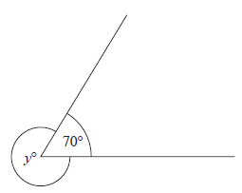
(a) Find the value of y.

y = .......................................................
(1)

(b) Give a reason for your answer.

......................................................................................................................................................

......................................................................................................................................................

......................................................................................................................................................
(1)
(Total for Question 2 is 2 marks)
___________________________________________________________________________

3
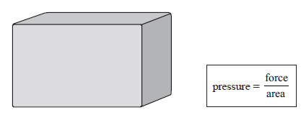

A storage tank exerts a force of 10 000 newtons on the ground.

The base of the tank in contact with the ground is a 4 m by 2 m rectangle.

Work out the pressure on the ground due to the tank.

....................................................... newtons / m²
(Total for Question 3 is 2 marks)
___________________________________________________________________________

4 Savio leaves his home at 07 30 to drive to work.

He drives a distance of 50 miles.

Savio thinks he drives at an average speed of 40 miles per hour.

(a) If Savio is correct, at what time will he arrive at work?

.......................................................
(3)
In fact, Savio’s average speed was greater than 40 miles per hour.

(b) How does this affect your answer to part (a)?

......................................................................................................................................................

......................................................................................................................................................

......................................................................................................................................................
(1)
(Total for Question 4 is 4 marks)
___________________________________________________________________________

5 Solve 7x − 27 < 8

.......................................................
(Total for Question 5 is 2 marks)
___________________________________________________________________________

6 There are 240 cans of drink on a shelf.
Each can contains cola or lemonade or orange.

the number of cans  of cola | : | the number of cans  of lemonade | : | the number of cans  of orange | = | 5 : 3 : 2

of the cans of lemonade and of the cans of orange are removed from the shelf.

Work out the number of cans of cola as a percentage of the total number of cans of
drink remaining on the shelf.

.......................................................%
(Total for Question 6 is 5 marks)
___________________________________________________________________________
7 Work out 0.004 × 0.32

.......................................................
(Total for Question 7 is 2 marks)
___________________________________________________________________________

8 Jenny drives from London to Swindon at an average speed of 54 miles per hour.
She drives for 1hours.

(a) Work out the distance from London to Swindon.

....................................................... miles
(2)

Aleksy is using a map.
The map has a scale of 1 : 25 000

On the map a road has a length of 6 cm.

(b) Work out the length, in kilometres, of the real road.

....................................................... kilometres
(3)
(Total for Question 8 is 5 marks)
___________________________________________________________________________
9 (a) Write 1.63 × 10⁻³ as an ordinary number.

.......................................................
(1)
(b) Write 438 000 in standard form.

.......................................................
(1)
(c) Work out (4 × 10³) × (6 × 10⁻⁵)
Give your answer in standard form.

.......................................................
(2)
(Total for Question 9 is 4 marks)
___________________________________________________________________________

10 At the end of October, Fiona’s electricity meter reads 88 738 kWh.
At the end of November, her electricity meter reads 89 198 kWh.

Each kWh of electricity Fiona uses costs 16p

Work out how much Fiona had to pay for the electricity she used in November.

.......................................................
(Total for Question 10 is 4 marks)
___________________________________________________________________________

11
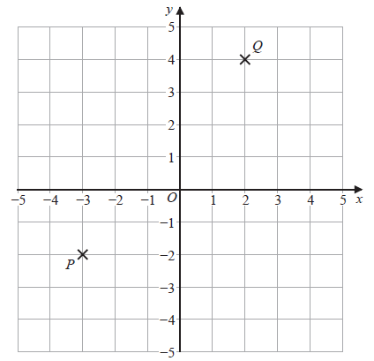

Find the coordinates of the midpoint of PQ.

( ............................ , ............................ )
(Total for Question 11 is 2 marks)
___________________________________________________________________________

12 Here are two triangles on a grid.
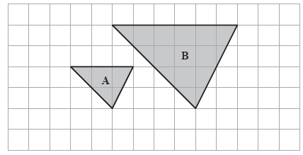
Triangle B is an enlargement of triangle A.

(a) (i) Write down the scale factor of the enlargement.

.......................................................
(1)
(ii) On the grid, mark with a cross (×) the centre of enlargement.
(1)

Here are two parallelograms on a coordinate grid.

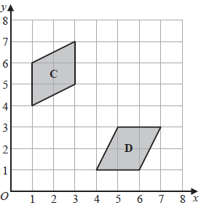

Parallelogram D is a reflection of parallelogram C.
(b) (i) On the grid, draw the mirror line.
(1)
(ii) Write down an equation of this mirror line.
.......................................................
(1)
(Total for Question 12 is 4 marks)
___________________________________________________________________________
13 (a) Work out
Give your answer as a mixed number.

.......................................................
(2)

(b) Show that

(2)
(Total for Question 13 is 4 marks)
___________________________________________________________________________

14 Write down the value of sin 30°

.......................................................
(Total for Question 14 is 1 mark)
___________________________________________________________________________

15 The centimetre grid shows the plan and the front elevation of a cylinder.

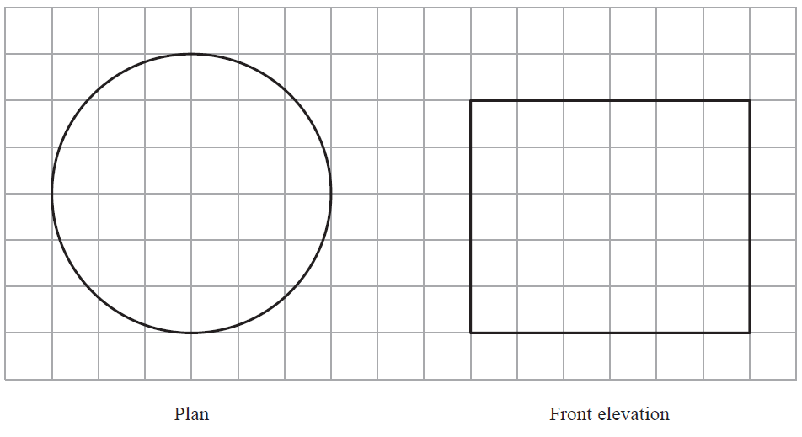

Work out the volume of the cylinder.
Give your answer in terms of π

....................................................... cm³
(Total for Question 15 is 3 marks)
___________________________________________________________________________

16 Here is a quadrilateral ABCD.
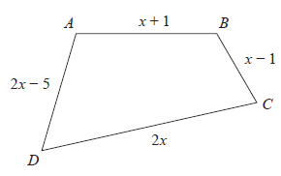

All the measurements are in centimetres.

The perimeter of ABCD is 52 centimetres.

Work out the length of DC.

....................................................... centimetres
(Total for Question 16 is 4 marks)
___________________________________________________________________________

17 Here is a regular hexagon and a regular pentagon.

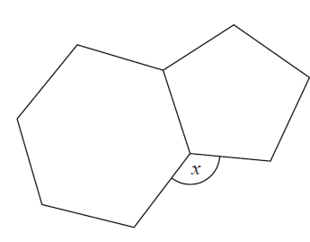

Work out the size of the angle marked x.
You must show all your working.

.......................................................°
(Total for Question 17 is 3 marks)
___________________________________________________________________________

18 (a) Complete the table of values for y = x² − 3x + 1

x | −1 | 0 | 1 | 2 | 3 | 4
y |  | 1 | −1
(2)

(b) On the grid, draw the graph of y = x² − 3x + 1 for values of x from −1 to 4

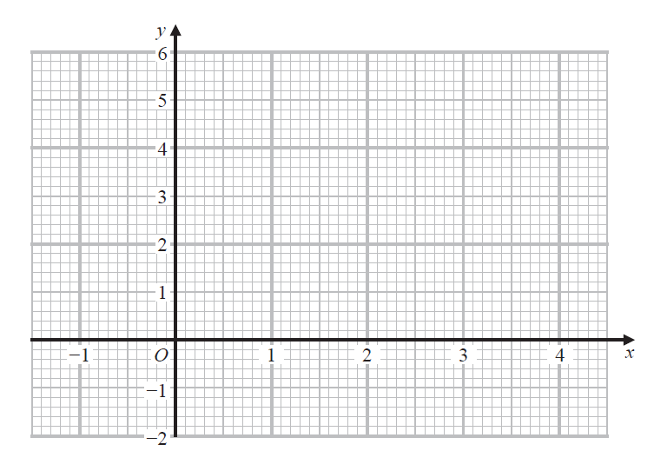

(2)
(c) Using your graph, find estimates for the solutions of the equation x² − 3x + 1 = 0

.......................................................
(2)
(Total for Question 18 is 6 marks)
___________________________________________________________________________

19 A car factory is going to make four different car models A, B, C and D.

80 people are asked which of the four models they would be most likely to buy.
The table shows information about the results.

Car model | Number of people
A | 23
B | 15
C | 30
D | 12

The factory is going to make 40 000 cars next year.

Work out how many model B cars the factory should make next year.

.......................................................
(Total for Question 19 is 2 marks)
___________________________________________________________________________

20 Rizwan writes down three numbers a, b and c

a : b = 1 : 3
b : c = 6 : 5

(a) (i) Find a : b : c

.......................................................
(2)

(ii) Express a as a fraction of the total of the three numbers a, b and c

.......................................................
(2)

Emma writes down three numbers m, n and p

n = 2m
p = 5n

(b) Find m : p

.......................................................
(2)
(Total for Question 20 is 6 marks)
___________________________________________________________________________

21 (a) Solve + 3 > 18

.......................................................
(3)

(b) Factorise x² + 10x + 9

.......................................................
(2)
(Total for Question 21 is 5 marks)
___________________________________________________________________________

22 Simplify (2⁻⁵ × 28)²

Give your answer as a power of 2

.......................................................
(Total for Question 22 is 2 marks)
___________________________________________________________________________

23 Here are two cubes, A and B.

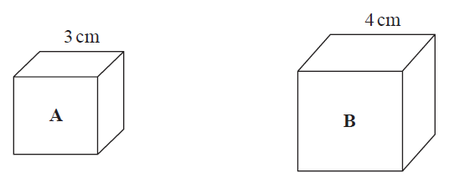
Cube A has a mass of 81 g.
Cube B has a mass of 128 g.
Work out

the density of cube A : the density of cube B

Give your answer in the form a : b , where a and b are integers.

.......................................................
(Total for Question 23 is 3 marks)
___________________________________________________________________________

24 The diagram shows three identical rectangles A, B and C.

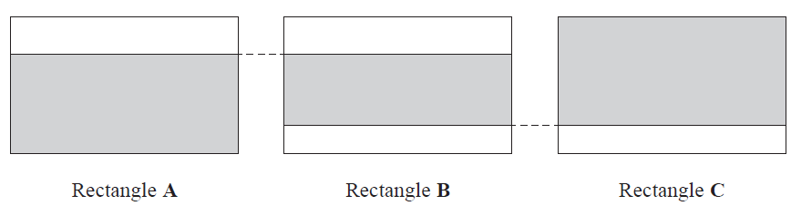

of rectangle A is shaded.

of rectangle C is shaded.

Work out the fraction of rectangle B that is shaded.

.......................................................
(Total for Question 24 is 3 marks)
___________________________________________________________________________

TOTAL FOR PAPER IS 80 MARKS

