Spring 2023 Practice Paper
Aiming for 5
Instructions
- Use black ink or ball-point pen.
  - Fill in the boxes at the top of this page with your name,
centre number and candidate number.
- Answer all questions.
- Answer the questions in the spaces provided
– there may be more space than you need.
- You must show all your working.
- Diagrams are NOT accurately drawn, unless otherwise indicated.
- Calculators may be used.
- If your calculator does not have a π button, take the value of π to be 3.142
unless the question instructs otherwise.
Information
- The total mark for this paper is 80. There are 24 questions.
- Questions have been arranged in an ascending order of mean difficulty, as found by students achieving Grade 4 in the Summer and November 2022 examinations.
- The marks for each question are shown in brackets
– use this as a guide as to how much time to spend on each question.
Advice
- Read each question carefully before you start to answer it.
- Keep an eye on the time.
- Try to answer every question.
- Check your answers if you have time at the end.

Answer ALL TWENTY FOUR questions.

Write your answers in the spaces provided.

You must write down all the stages in your working.

1 The scatter graph shows information about the amount of rainfall, in mm, and the
number of hours of sunshine for each of ten English towns on the same day.

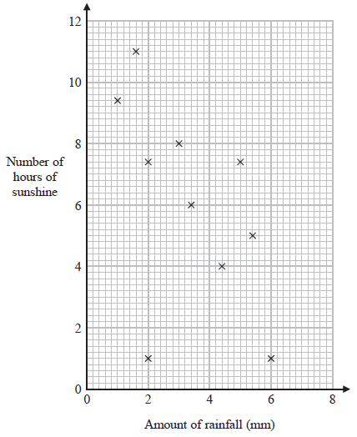

One of the points is an outlier.

(a) Write down the coordinates of this point.
( ............................ , ............................ )
(1)
(b) Ignoring the outlier, describe the relationship between the amount of rainfall and the
number of hours of sunshine.

......................................................................................................................................................

......................................................................................................................................................

......................................................................................................................................................
(1)
On the same day in another English town there were 7 hours of sunshine.

(c) Using the scatter graph, estimate the amount of rainfall in this town on this day.

....................................................... mm
(2)
(Total for Question 1 is 4 marks)
___________________________________________________________________________

2 Festival A will be in a rectangular field with an area of 80 000 m²
The greatest number of people allowed to attend Festival A is 425
Festival B will be in a rectangular field 700 m by 2000 m.
The greatest number of people allowed to attend Festival B is 6750
The area per person allowed for Festival B is greater than the area per person allowed
for Festival A.
(a) How much greater?
Give your answer correct to the nearest whole number.

...................................................... m²
(4)
Callum says,

“300 cm² is the same as 3 m² because there are 100 cm in 1 m so you divide by 100”

Callum’s method is wrong.
(b) Explain why.

......................................................................................................................................................

......................................................................................................................................................

......................................................................................................................................................
(1)
(Total for Question 2 is 5 marks)
___________________________________________________________________________
3 Nimra buys a 3 kg box of sweets for £17.60
She puts the sweets into bags to sell.
Each bag contains 150 g of sweets.
Nimra fills as many bags as possible.
She will sell each bag for the same price.
Nimra wants to make a profit of at least 35%
Assuming she sells all the bags,
what is the lowest price Nimra should charge for each bag?

£....................................................
(Total for Question 3 is 5 marks)
___________________________________________________________________________
4 A shop has two different special offers on milk.

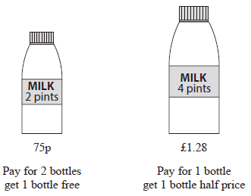

Which offer gives the better value for money?
You must show how you get your answer.

(Total for Question 4 is 4 marks)
___________________________________________________________________________

5 (a) Simplify (x³)⁵

....................................................
(1)
(b) Expand and simplify 4(x + 3) + 7(4 − 2x)

................................................................................
(2)
(c) Factorise fully 15x³ + 3x²y

................................................................................
(2)
(Total for Question 5 is 5 marks)
___________________________________________________________________________

6 Here are the first five terms of an arithmetic sequence.

7 | 13 | 19 | 25 | 31

(a) Find an expression, in terms of n, for the nth term of this sequence.

.......................................................
(2)
The nth term of a different sequence is 8 − 6n

(b) Is −58 a term of this sequence?
You must show how you get your answer.

(2)
(Total for Question 6 is 4 marks)
___________________________________________________________________________

7 A new phone cost £679
The value of the phone decreases at a rate of 4% per year.
Work out the value of the phone at the end of 3 years.

£....................................................
(Total for Question 7 is 3 marks)
___________________________________________________________________________
8 This sign was in a doctor’s waiting room.

115 appointments were missed last month.
These missed appointments were a total of 25.3 hours.

Work out the mean length of time for each missed appointment.
Give your answer in minutes.

...................................................... minutes
(Total for Question 8 is 3 marks)
___________________________________________________________________________

9 The table shows information about the number of social media accounts used by each of
300 students.

Number of social media accounts | Frequency
0 | 3
1 | 57
2 | 84
3 | 75
4 | 81

(a) Work out the total number of social media accounts used by these students.

....................................................
(2)
(b) Find the median number of social media accounts used by these students.

....................................................
(2)
(Total for Question 9 is 4 marks)
___________________________________________________________________________

10 Water flows through each of the pipes that fill a lake at the same rate.
It takes 4 of the pipes 12 hours to fill the lake.
Work out how many hours it would take 6 pipes to fill of the lake.

....................................................... hours
(Total for Question 10 is 3 marks)
___________________________________________________________________________

11 Ella invests £7000 for 2 years in an account paying compound interest.

In the first year, the rate of interest is 3%
In the second year, the rate of interest is 1.5%

Work out the value of Ella’s investment at the end of 2 years.

£.......................................................
(Total for Question 11 is 3 marks)
___________________________________________________________________________

12 Lorena gets a train at the same time each morning to go to work.
She gets a train at the same time each evening to come home.
The probability tree diagram shows the probabilities of each train arriving late.
(a) Complete the probability tree diagram.
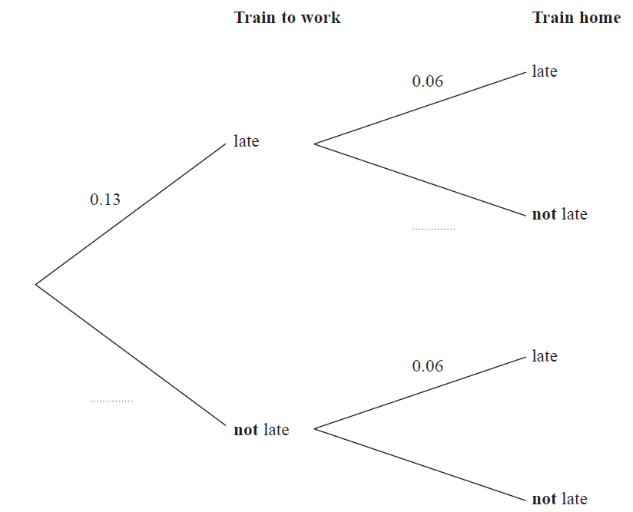............
(2)
For a day that Lorena goes to work,
(b) work out the probability that the train to work and the train home will both arrive late.

....................................................
(2)
(Total for Question 12 is 4 marks)
___________________________________________________________________________

13 Here is the graph of y = x² − 6x + 4

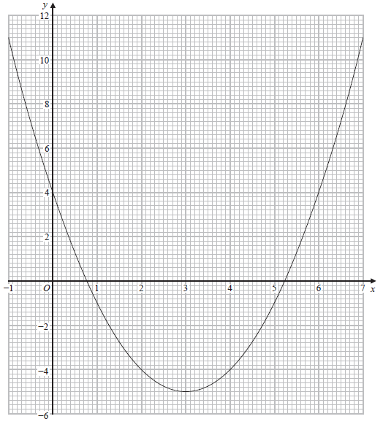

(a) Write down the y intercept of the graph of y = x² − 6x + 4

.......................................................
(1)
(b) Write down the coordinates of the turning point of the graph of y = x² − 6x + 4

( ............................ , ............................ )
(1)
(c) Use the graph to find estimates for the roots of x² − 6x + 4 = 0

.......................................................
(2)
(Total for Question 13 is 4 marks)
___________________________________________________________________________

14 Here are four cards.
There is a number on each card.

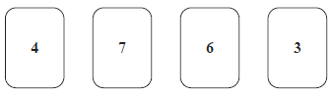

Write down the smallest 4-digit even number that can be made using each card only once.

.......................................................
(Total for Question 14 is 1 mark)
___________________________________________________________________________

15 The length of a football pitch is 90 metres, correct to the nearest metre.
Complete the error interval for the length of the football pitch.

............................ m ≤ length < ............................ m
(Total for Question 15 is 2 marks)
___________________________________________________________________________
16 Solve the simultaneous equations
5x + 2y = 27
6x + 4y = 28

x = ....................................................

y = ....................................................
(Total for Question 16 is 3 marks)
___________________________________________________________________________

17 The table shows information about the heights of 80 teenagers.

Height (h cm) | Frequency
150 < h ≤ 160 | 8
160 < h ≤ 170 | 14
170 < h ≤ 180 | 24
180 < h ≤ 190 | 30
190 < h ≤ 200 | 4

Work out an estimate for the mean height of the teenagers.

....................................................... cm
(Total for Question 17 is 3 marks)
___________________________________________________________________________

18 The diagram shows a plan of Jason’s garden.

ABCO and DEFO are rectangles.
CDO is a right-angled triangle.

AFO is a sector of a circle with centre O and angle AOF = 90°

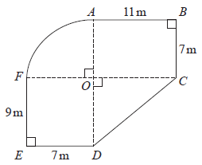

Jason is going to cover his garden with grass seed.

Each bag of grass seed covers 14 m² of garden.
Each bag of grass seed costs £10.95

Work out how much it will cost Jason to buy all the bags of grass seed he needs.

£.......................................................
(Total for Question 18 is 5 marks)
___________________________________________________________________________

19 (a) Find the value of the reciprocal of 0.8

.......................................................
(1)
x = 4700 correct to 2 significant figures.

(b) Complete the error interval for x.

............................ ≤ x < ............................
(2)
(Total for Question 19 is 3 marks)
___________________________________________________________________________

20
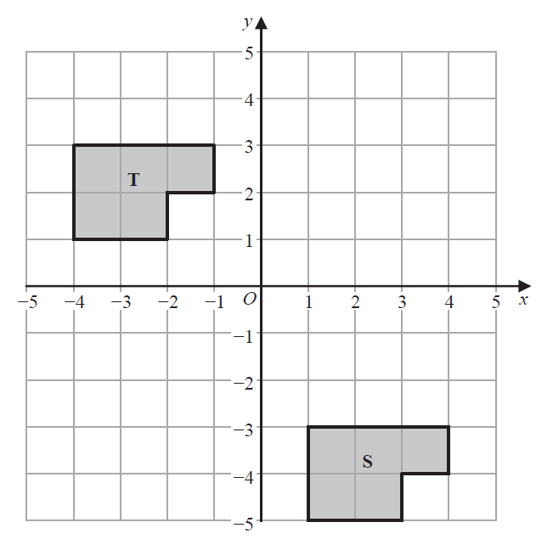

Describe fully the single transformation that maps shape S onto shape T.

......................................................................................................................................................

......................................................................................................................................................
(Total for Question 20 is 2 marks)
___________________________________________________________________________
21
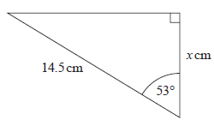

Work out the value of x.
Give your answer correct to 3 significant figures.

x = .......................................................
(Total for Question 21 is 2 marks)
___________________________________________________________________________

22 The front elevation and the plan of a solid are shown on the grid.
On the grid, draw the side elevation of the solid from the direction of the arrow.

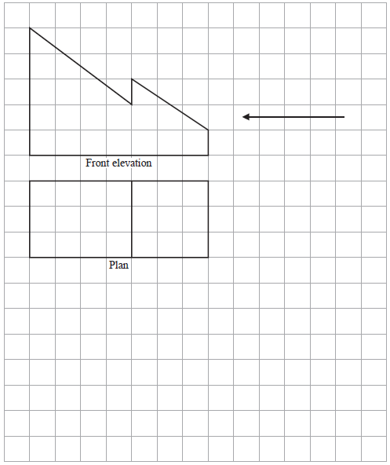

(Total for Question 22 is 2 marks)
___________________________________________________________________________

23 The population of a town increased by 9% between 2018 and 2019
The population in 2019 was 165 680

Calculate the population in 2018

.......................................................
(Total for Question 23 is 2 marks)
___________________________________________________________________________

24 The points L, M and N are such that LMN is a straight line.
The coordinates of L are (−3, 1)
The coordinates of M are (4, 9)
Given that LM : MN = 2 : 3,
find the coordinates of N.

(.............. , ..............)
(Total for Question 24 is 4 marks)
___________________________________________________________________________

TOTAL FOR PAPER IS 80 MARKS

