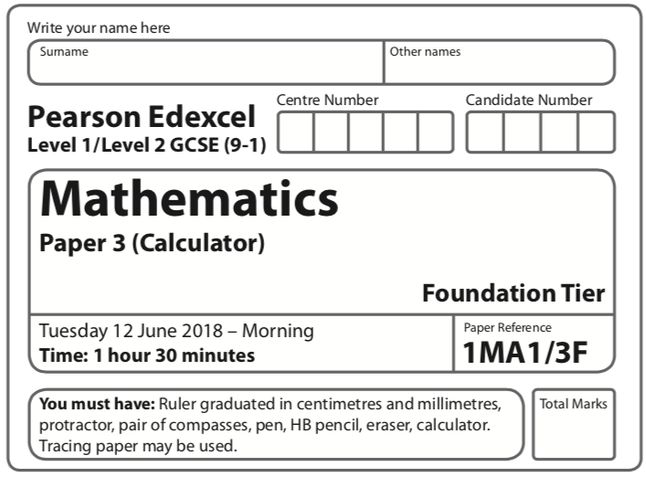
Spring 2023 Practice Paper
Aiming for 5
Instructions
- Use black ink or ball-point pen.
  - Fill in the boxes at the top of this page with your name,
centre number and candidate number.
- Answer all questions.
- Answer the questions in the spaces provided
– there may be more space than you need.
- You must show all your working.
- Diagrams are NOT accurately drawn, unless otherwise indicated.
- Calculators may be used.
- If your calculator does not have a π button, take the value of π to be 3.142
unless the question instructs otherwise.
Information
- The total mark for this paper is 80. There are 26 questions.
- Questions have been arranged in an ascending order of mean difficulty, as found by students achieving Grade 4 in the Summer and November 2022 examinations.
- The marks for each question are shown in brackets
– use this as a guide as to how much time to spend on each question.
Advice
- Read each question carefully before you start to answer it.
- Keep an eye on the time.
- Try to answer every question.
- Check your answers if you have time at the end.

Answer ALL TWENTY SIX questions.

Write your answers in the spaces provided.

You must write down all the stages in your working.

1 Here is the shoe size of each of 12 boys in a class.

4 | 5 | 6 | 6 | 6 | 7 | 7 | 8 | 8 | 8 | 8 | 9

(a) Find the median.

......................................................
(1)
(b) Work out the range.

......................................................
(1)
For the shoe sizes of each of 12 girls in the class,

the median size is 6
the range is 3

(c) Compare the distribution of the shoe sizes of the boys with the distribution of the
shoe sizes of the girls.

......................................................................................................................................................

......................................................................................................................................................

......................................................................................................................................................

......................................................................................................................................................

......................................................................................................................................................

......................................................................................................................................................
(2)
(Total for Question 1 is 4 marks)
___________________________________________________________________________

2 ABCD is a quadrilateral.
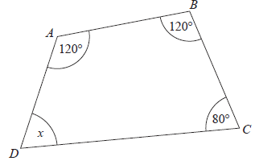

(a) (i) Work out the size of angle x.

.......................................................°
(1)
(ii) Give a reason for your answer.

......................................................................................................................................................

......................................................................................................................................................
(1)

The diagram below shows a triangle.
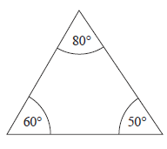
The diagram is wrong.
(b) Explain why.

......................................................................................................................................................

......................................................................................................................................................

......................................................................................................................................................
(1)
(Total for Question 2 is 3 marks)
___________________________________________________________________________

3 Work out the lowest common multiple (LCM) of 24 and 56

......................................................
(Total for Question 3 is 2 marks)
___________________________________________________________________________

4 The accurately drawn map shows the positions of three points, A, B and C, in a field.

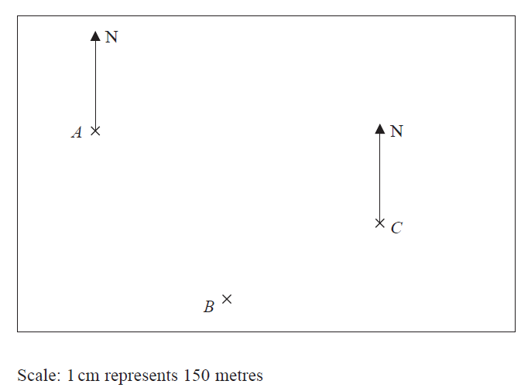
Parveen walks in a straight line from A to B.
She then walks in a straight line from B to C.
Susan walks in a straight line from A to C.
Parveen walks more metres than Susan.
(a) How many more?

...................................................... metres
(3)
(b) Find by measurement the bearing of A from C.

......................................................°
(1)
(Total for Question 4 is 4 marks)
___________________________________________________________________________
5 a = b = c =

(a) Work out as a column vector

(i) a + b
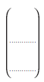
(1)

(ii) 2a − c

(2)

The vector d is drawn on the grid.

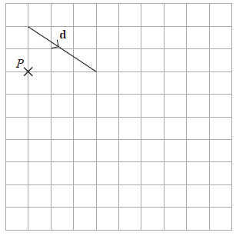

(b) From the point P, draw the vector 2d
(1)
(Total for Question 5 is 4 marks)
___________________________________________________________________________

6 Carly cycles to her friend’s house.

She stays at her friend’s house for a number of minutes.
Then she cycles home.

Here is the travel graph for her journey.

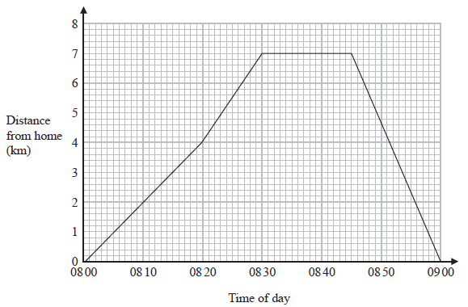

(a) For how many minutes did Carly stay at her friend’s house?

....................................................... minutes
(1)
(b) How far is Carly from her home at 08 50?

....................................................... km
(1)
(c) Work out Carly’s speed, in km/h, for the first 20 minutes of her journey.

....................................................... km/h
(2)
(Total for Question 6 is 4 marks)
___________________________________________________________________________
7 On the centimetre grid, draw an isosceles triangle with an area of 12 cm²

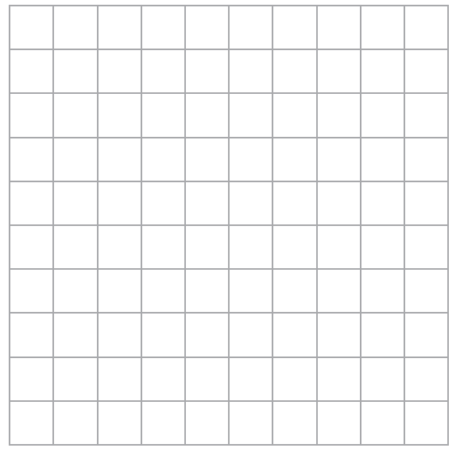

(Total for Question 7 is 2 marks)
___________________________________________________________________________

8 (a) Write 2530 correct to 2 significant figures.

......................................................
(1)
(b) Write 0.0874 correct to 1 significant figure.

......................................................
(1)
(Total for Question 8 is 2 marks)
___________________________________________________________________________

9 One weekend the Keddie family is going to do a sports quiz and a music quiz.

The probability that the family will win the sports quiz is 0.3
The probability that the family will win the music quiz is 0.35

(a) Complete the probability tree diagram.

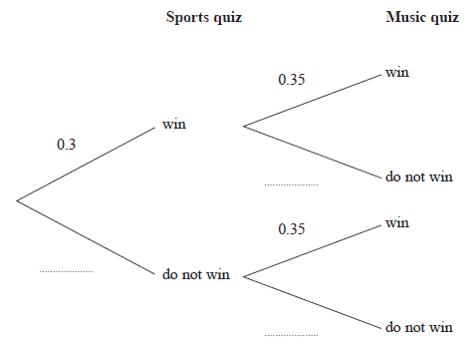
(2)

(b) Work out the probability that the Keddie family will win both the sports quiz and the
music quiz.

.......................................................
(2)
(Total for Question 9 is 4 marks)
___________________________________________________________________________
10 (a) Write 6.75 × 10⁻⁴ as an ordinary number.

.......................................................
(1)
(b) Work out

Give your answer in standard form.

.......................................................
(2)
(Total for Question 10 is 3 marks)
___________________________________________________________________________

11 There are three different types of potato in a box.
The table gives the number of each type of potato.

Type of potato | Number of potatoes
Jersey Royal | 90
Charlotte | 105
Maris Piper | 105

Salim draws this pie chart for the information in the table.

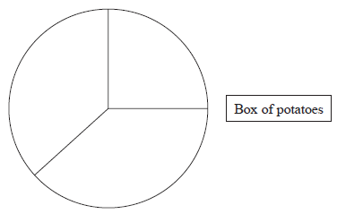
Write down two different things that are wrong or misleading with this pie chart.

1....................................................................................................................................................

......................................................................................................................................................

2....................................................................................................................................................

......................................................................................................................................................
(Total for Question 11 is 2 marks)
___________________________________________________________________________

12 The table gives information about the lengths, in cm, of some pieces of string.

Length (t cm) | Frequency
0 < t ≤ 10 | 15
10 < t ≤ 20 | 20
20 < t ≤ 30 | 50
30 < t ≤ 40 | 25
40 < t ≤ 50 | 5

Amos draws a frequency polygon for the information in the table.
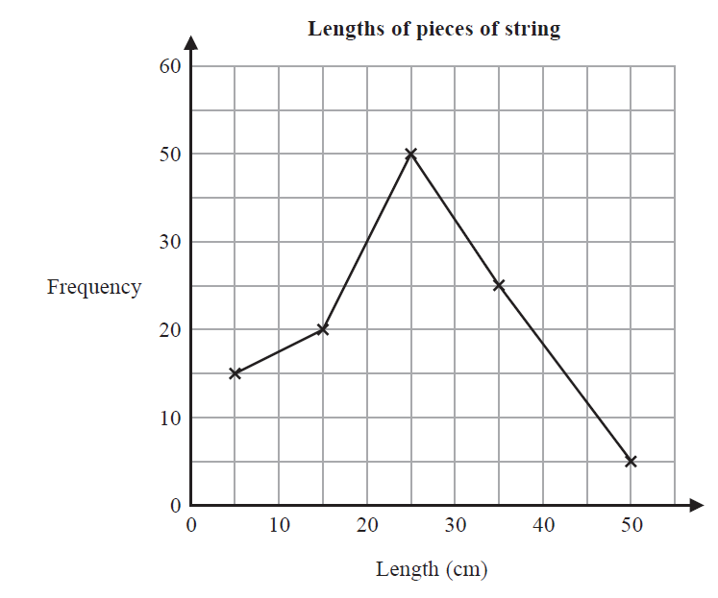
Write down two mistakes that Amos has made.

1....................................................................................................................................................

......................................................................................................................................................

2....................................................................................................................................................

......................................................................................................................................................
(Total for Question 12 is 2 marks)
___________________________________________________________________________
13
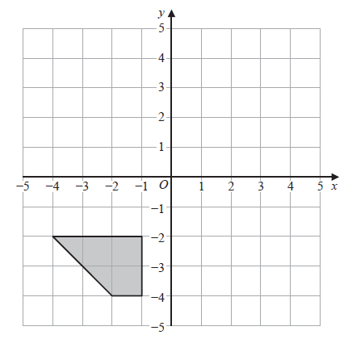

Rotate the shaded shape 90° anticlockwise about (0, 0)

(Total for Question 13 is 2 marks)
___________________________________________________________________________

14 Rick, Selma and Tony are playing a game with counters.
Rick has some counters.
Selma has twice as many counters as Rick.
Tony has 6 counters less than Selma.
In total they have 54 counters.

the number of counters Rick has : the number of counters Tony has = 1 : p

Work out the value of p.

p = ......................................................
(Total for Question 14 is 5 marks)
___________________________________________________________________________

15 In the diagram, PQR is an isosceles triangle with PQ = PR.

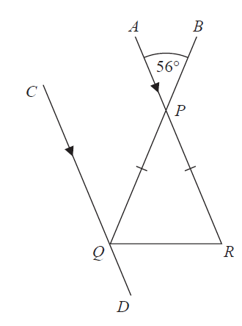

APR and CQD are parallel lines.
BPQ is a straight line.
Angle APB = 56°
Work out the size of angle CQR.
Give a reason for each stage of your working.

(Total for Question 15 is 5 marks)
___________________________________________________________________________
16
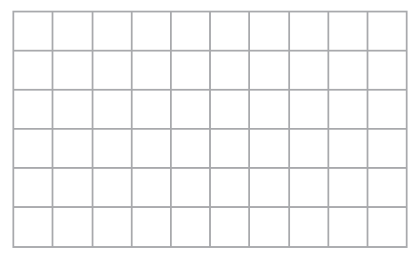

On the grid, draw a quadrilateral with
no lines of symmetry
and rotational symmetry of order 2

(Total for Question 16 is 2 marks)
___________________________________________________________________________

17 Here is a right-angled triangle.

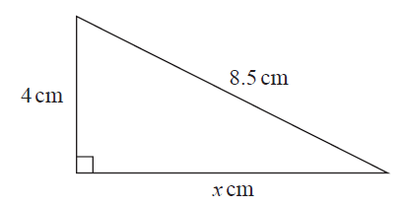
Work out the value of x.

x = ......................................................
(Total for Question 17 is 2 marks)
___________________________________________________________________________
18 T = 4m² − 11

(a) Work out the value of T when m = − 3

T = ......................................................
(2)
(b) Make p the subject of the formula d = 3p + 4

......................................................
(2)
(Total for Question 18 is 4 marks)
___________________________________________________________________________

19 Jessica runs for 15 minutes at an average speed of 6 miles per hour.
She then runs for 40 minutes at an average speed of 9 miles per hour.
It takes Amy 45 minutes to run the same total distance that Jessica runs.
Work out Amy’s average speed.
Give your answer in miles per hour.

...................................................... miles per hour
(Total for Question 19 is 4 marks)
___________________________________________________________________________

20 Make a the subject of the formula p = 3a − 9

.......................................................
(Total for Question 20 is 2 marks)
___________________________________________________________________________

21 Change 30 metres per second to kilometres per hour.

...................................................... kilometres per hour
(Total for Question 21 is 2 marks)
___________________________________________________________________________

22 The value of Michelle’s car has decreased by 15%
The car now has a value of £13 600
Work out the value of Michelle’s car before the decrease.

£......................................................
(Total for Question 22 is 2 marks)
___________________________________________________________________________

23 (a) Change 8000 cm³ to m³

....................................................... m³
(1)

(b) Change a speed of 180 km per hour to metres per second.

....................................................... metres per second
(3)
(Total for Question 23 is 4 marks)
___________________________________________________________________________

24 There are 30 women and 20 men at a gym.

The mean height of all 50 people is 167.6 cm
The mean height of the 20 men is 182 cm

Work out the mean height of the 30 women.

....................................................... cm
(Total for Question 24 is 3 marks)
___________________________________________________________________________

25 Karina has 4 tanks on her tractor.
Each tank is a cylinder with diameter 80 cm and height 160 cm.

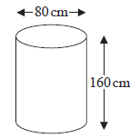

The 4 tanks are to be filled completely with a mixture of fertiliser and water.
The fertiliser has to be mixed with water in the ratio 1 : 100 by volume.

Karina has 32 litres of fertiliser.
1 litre = 1000 cm³

Has Karina enough fertiliser for the 4 tanks?
You must show how you get your answer.

(Total for Question 25 is 4 marks)
___________________________________________________________________________
26 The diagram shows rectangle STUV.
TQU and SRV are straight lines.
All measurements are in cm.

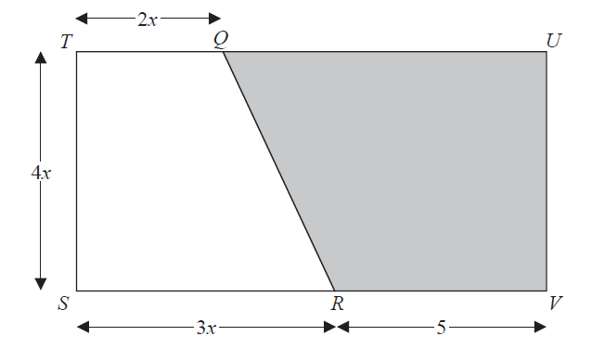

The area of trapezium QUVR is A cm²
Show that A = 2x² + 20x

(Total for Question 26 is 3 marks)
___________________________________________________________________________

TOTAL FOR PAPER IS 80 MARKS

